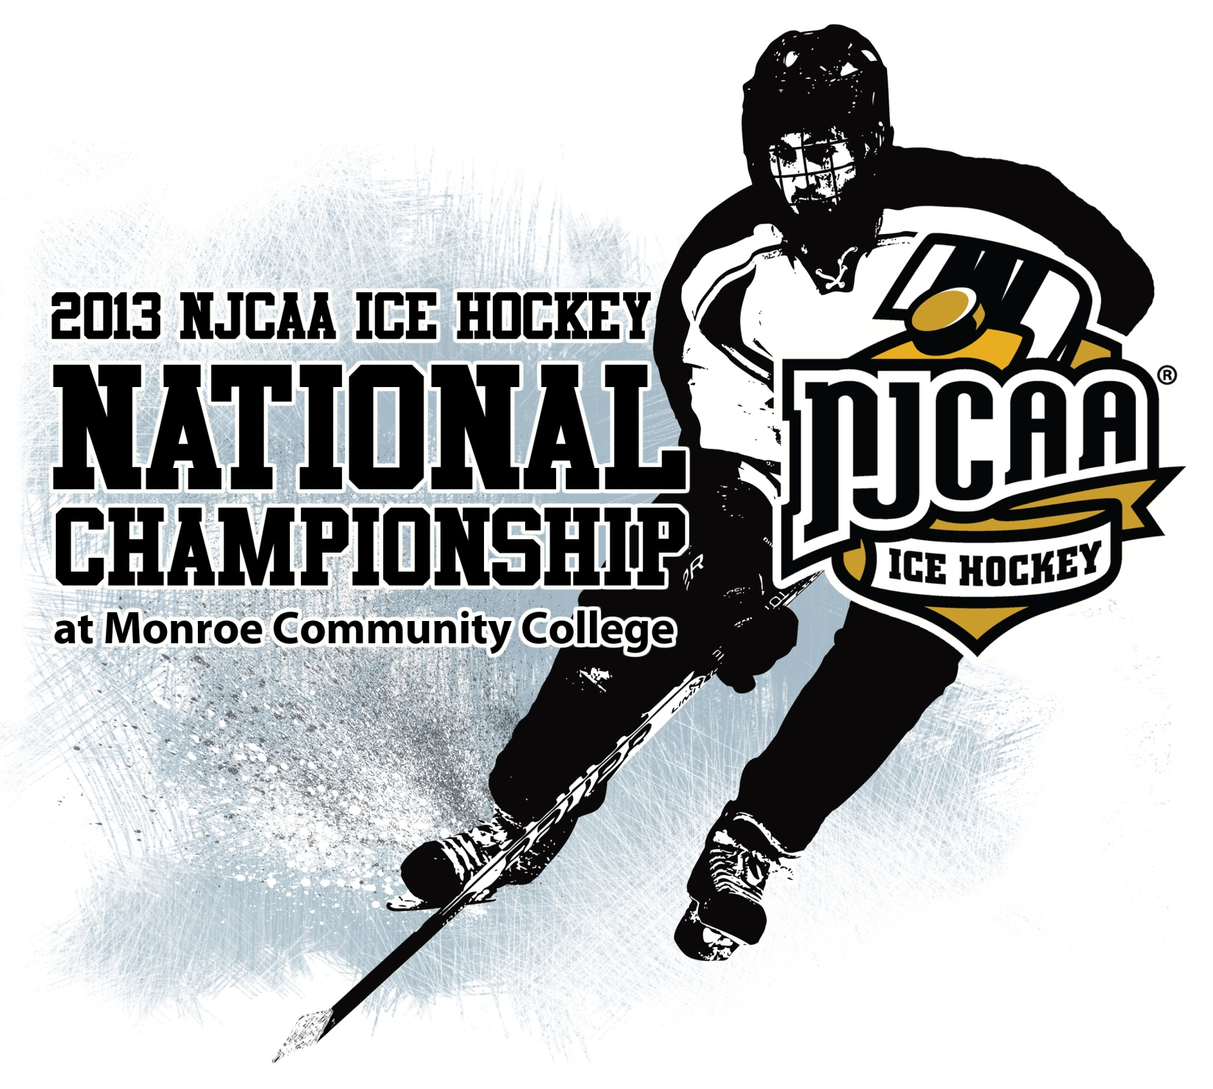

FEBRUARY 23-24, 2013
MONROE COMMUNITY COLLEGE
ROCHESTER, NEW YORK

2013 NJCAA ICE HOCKEY NATIONAL CHAMPIONSHIP

Tournament Site: The Sports Centre at MCC
Monroe Community College
1000 E. Henrietta Road
Rochester, NY 14623

Dates: February 23-24, 2013

Tournament Contacts: Dudley “Skip” Bailey
Director of Athletics
Office: (585) 292-2833
dbailey@monroecc.edu
Fax: (585) 292-3845

Tim Parrinello
Assistant Athletic Director
Office: (585) 292-2837
tparrinello@monroecc.edu

Tom Garigen
Assistant Athletic Director/SID
Office: (585) 292-2834
tgarigen@monroecc.edu

Tournament Website: Game recaps and other information will be posted on MCC’s website. The tournament’s site can be found at http://www.mcctribunes.com/information/2013_NJCAA_Ice_Hockey_National_Tournament.

Roster/Photos/Logos: Please e-mail a team photo in color, team logo, and rosters (using the enclosed form) as attachments to Tom Garigen at tgarigen@monroecc.edu by Friday, Feb. 8. Please send this information even if you are unsure you have qualified for the tournament. Submit all photos by using the following specifications:

Team Photo (in color)
- .TIF or .JPG file format
- 300 dpi resolution
Team and Mascot Logos
- .TIF, .JPG or EPS file format
- 300 dpi resolution (or EPS vector)
Lodging: All participating tournament teams will be housed directly across from Monroe Community College at the Country Inn and Suites. Contact information is below. All teams must stay at the County Inn and Suites

Country Inn and Suites
Contact: Pinkesh Patel
797 East Henrietta Road
Rochester, NY 14623
Phone: (585) 427-0131

A block of rooms are on reserve under MCC for teams,
coaches and staff only at a rate of $89 per night. Rooms are being held until Feb. 15, 2012. In order to receive the rate, you must book by this date.

Family and spectators of the participating tournament teams may consider the following:

Holiday Inn and Suites
Contact: Manoj Patel
800 Jefferson Road
Rochester, NY 14623
Phone: (585) 475-9190

T-Shirts: An ordering form for tournament apparel (t-shirts, hoodies, hats) will come separately.

Banquet: The team banquet will be on Feb. 22 from 5:30-8 p.m. in the
R. Thomas Flynn Campus Center at Monroe Community
College. The order form is included in this packet. Tickets are $10 per attendee.

NJCAA Coaches Meeting: The NJCAA Ice Hockey Coaches Meeting will take place on Friday, Feb. 22, immediately after the team banquet. It will be held at Delmonico’s Steakhouse, across the street from MCC.

Athletic Trainers: An athletic trainer will be available during the entire tournament, including practices. Each participating team must provide its own medical kit and training supplies. An overview of what is being offered is included in this document.

Ticket Prices: General Admission: $10 Weekend Pass
$5 Per Day

Children 14 and under: FREE
With MCC ID FREE

Each team will receive tournament passes based upon their official roster. The pass must be displayed at all times to gain entry into the ice arena. Each player and coach will receive a complimentary program.

Programs: Additional programs may be purchased for $2 each.

Rules and Guidelines: The 2013 NJCAA Hockey Tournament will run in accordance with the NJCAA rules and regulations and NCAA playing rules. Each participating team may dress a maximum of 18 skaters plus up to 3 goaltenders. (Must dress at least two). A three-man officiating system will be used consisting of two referees and one assistant referee. The officials for the championship game will not have officiated any of the previous tournament games.

Skate Sharpening: Skate sharpening will be available through Locker Room Sports at the arena for a $6 fee per set of skates. Sharpening will be available during all practice sessions and prior to and during all games.

Official Scorebook: The official scorebook will be kept by Monroe Community College. Competing teams may keep their own, but those sheets are unofficial.

Hospitality Room: A hospitality room for coaches, college personnel, media and staff will be at the Sports Centre rink. You must show your tournament pass to gain entrance to the room.

Awards: There will be an awards ceremony immediately following the Championship Game. Awards presented will include the
Champion and Runner-up trophies, plus individual medals for the winning team. Other awards include Coach of the Tournament, an All-Tournament team consisting of seven players, and Tournament MVP.

Tournament Format
2013 NJCAA Ice Hockey National Championship

Tournament Format: The NJCAA Ice Hockey Tournament will be a seeded four team tournament. The tournament will be seeded by the National Ice Hockey Committee. Participating teams for this tournament will consists of the top two (2) teams of the Eastern JUCO Hockey League and two (2) at-large teams. In the event any of the at-large teams are not filled, the number three and four teams of the Eastern JUCO Hockey League will qualify respectively.

Friday, February 22nd:
Practice Schedule: 12 p.m. – 1 p.m. #2 SEED
1 p.m. – 2 p.m. #1 SEED
2 p.m. – 3 p.m. #3 SEED
3 p.m. – 4 p.m. #4 SEED

If you select NOT to use your practice slot, please contact MCC Athletic Director Skip Bailey at dbailey@monroecc.edu or (585) 292-2833.

Locker Room Assignments:
Teams advancing into the Championship game will be allowed to keep their equipment in their locker rooms Saturday night.

Coaches Meeting:
There will be a tournament and JUCO coaches meeting at Delmonico’s Steakhouse following the banquet. This is a mandatory meeting for coaches.

Saturday, February 23^{rd:}
Game 1: 12:22 p.m. warm-up Visitor Home
1 p.m. face off #4 seed vs. #1 seed
(DARK) (LIGHT)

3 p.m.: Recognition/Awards ceremony for Region III Hockey

Game 2: 3:52 p.m. warm-up Visitor Home
4:30 p.m. face off #3 seed vs. #2 seed
(DARK) (LIGHT)
Sunday, February 24th:
Championship: 1:22 p.m. warm-up Lower remaining seed will be Visitor
2 p.m. face off Highest remaining seed will be Home

Award Ceremony: Following the Championship Game

***PLEASE BRING BOTH SETS OF UNIFORMS TO THE TOURNAMENT***

IMPORTANT DATES AND DEADLINES
2013 NJCAA Ice Hockey National Championship

FRIDAY, FEBRUARY 1

Intent to Compete Form

FRIDAY, FEBRUARY 8

Roster/Team Information Form Due

Team Photo Due (color 300 dpi)

College Mascot/Logo Due
(color 300 dpi)

Banquet Reservation/Media Form Due

DECLARATION OF INTENT TO COMPETE
2013 NJCAA Ice Hockey National Championship

__________________________: Wishes to be considered for selection and seeding into
(College Name) the NJCAA Ice Hockey National Tournament.

Signed:_______________________________________
ATHLETIC DIRECTOR

Signed:________________________________________
HEAD COACH

Date:__________________________________________

______________________________: Does not wish to be considered for the selection and seeding
Into the NJCAA ICE Hockey National Tournament.

Signed:_______________________________________
ATHLETIC DIRECTOR

Signed:________________________________________
HEAD COACH

Date:__________________________________________

Please FAX this form by FRIDAY, FEBRUARY 1st to:

Skip Bailey, Director of Athletics
FAX: (585) 292-3845
Email: dbailey@monroecc.edu

OFFICIAL ROSTER FORM (Due Friday, Feb. 8)
2013 NJCAA Ice Hockey National Championship

College:
School Mascot/Nickname:
School Colors:

#  (H/A) | Name | Yr. | Pos. | Ht.  (ex. 6-0) | Wt. | Hometown  (city, state) | High School

Head Coach:
Assistant Coaches:
Athletic Director:
Athletic Trainer:
Other Personnel Requiring Credentials:

BANQUET ORDER FORM (Due Friday, Feb. 8)
2013 NJCAA Ice Hockey National Championship

Monroe Community College will host a banquet on Friday, Feb. 22 in the R. Thomas Flynn Campus Center on the MCC campus. The banquet will begin with a reception at 5:30 p.m. and a guest speaker at 6 p.m., with dinner to follow. The banquet cost is $10 per ticket.

College Name:

Number Attending: x $10.00 per ticket

Total Amount included:

Banquet Notes:
- Attire: Please wear a shirt and tie
- Gift bags will be presented to each player and coach in attendance
- Please make checks payable to “MCC Association, Inc.”
- Send checks to: Skip Bailey, Director of Athletics
Monroe Community College
1000 E. Henrietta Road
Rochester, NY 14623

MEDIA INFORMATION (Due Friday, Feb. 8)
2013 NJCAA Ice Hockey National Championship

Please fill out and return this media information if you would like our staff to send scores and game recaps as the tournament is in progress.

College Name: ______________________________________________

Head Coach: ________________________________________________

Media Name Fax Number E-Mail
____________________________________ (______) ______-_________
____________________________________ (______) ______-_________
____________________________________ (______) ______-_________

Please only list three media outlets. Thank You!!
Athletic Training Coverage
2013 NJCAA Ice Hockey National Championship

A certified athletic trainer will be available for treatment of athletic injuries. If you are traveling without a certified athletic trainer and have an athlete who needs treatment, he may utilize the athletic trainer onsite during the tournament.

Any injured athlete needing treatment must provide the athletic trainer with a written diagnosis and treatment protocol for the injury.

Athletes who obtain injuries during tournament will be evaluated and treated in accordance with New York State law.

Note: For any certified athletic trainer traveling with the team, we will have ice, moist heat, ultrasound and electrical stimulation modalities available for use.
Water coolers will also be available.

Each team will be responsible to bring its own taping supplies.

Training Room Hours:

Saturday, February 23, 2013
10 a.m. through the end of the second game

Sunday, February 24, 2013
11:30 a.m. until the end of game

Important phone numbers:
Mike Cerame MS, ATC
Head Athletic Trainer
Office: (585)-292-2857
Cell: (585)-490-1096

Mary Salluzzo MS, ATC
Asst. Athletic Trainer
Office: (585)-292-2850

University of Rochester Medical Center
Strong Memorial Hospital
601 Elmwood Avenue
Emergency Dept # 585-273-4041

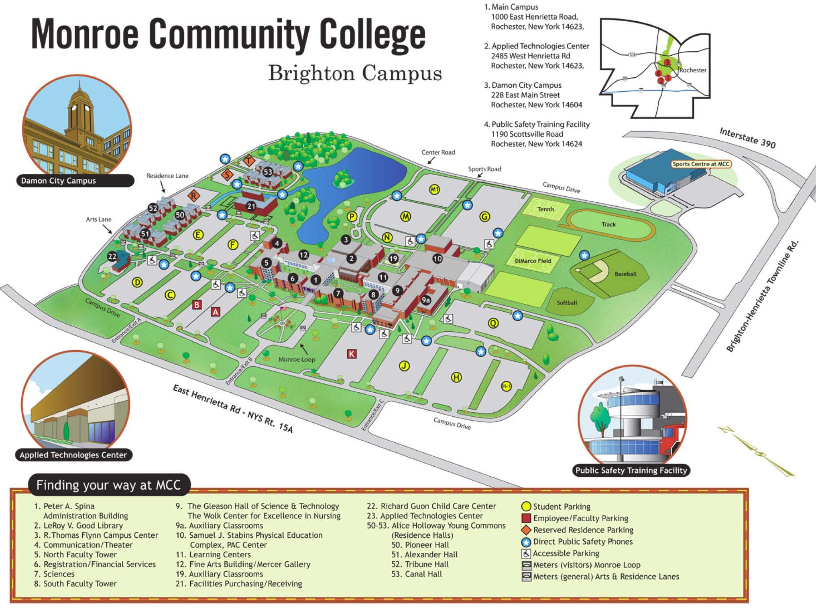

MCC Brighton Campus | 1000 East Henrietta Road  Rochester, NY 14623  585-292-2000
To reach the MCC Brighton Campus from:
The West (Buffalo) | Take Thruway 90 east to exit 46; take 390 north to exit 16, the second East Henrietta Rd. (Rt. 15A) exit; turn left and continue south on 15A for about 1/2 mile to the main campus entrance.
The East (Syracuse) | Take Thruway 90 west to exit 46 and proceed as above.
South (Geneseo) | Take 390 north to exit 16 - the second East Henrietta Road exit and proceed as above.
Brockport/Spencerport | Take Route 531 east to 490 east and then to 390 south; take exit 16B (East Henrietta Rd. - Rt. 15A); turn right and proceed for about 1/2 mile to the main campus.

